04 September 2026  For HR staff  Recruiters  Administrators  Modi Furniture |  | Recruitment FMS User Guide  Use this guide to manage a job opening from the initial manpower request through application screening, interviews, offers, joining and closure. It also explains the public candidate form, staff accounts, reports and the technical setup.  Start with the right record  A vacancy is the job opening. A candidate is one person applying for that opening. The Requirement ID links them. Vacancy status, vacancy workflow stage, candidate stage and screening status are separate controls.  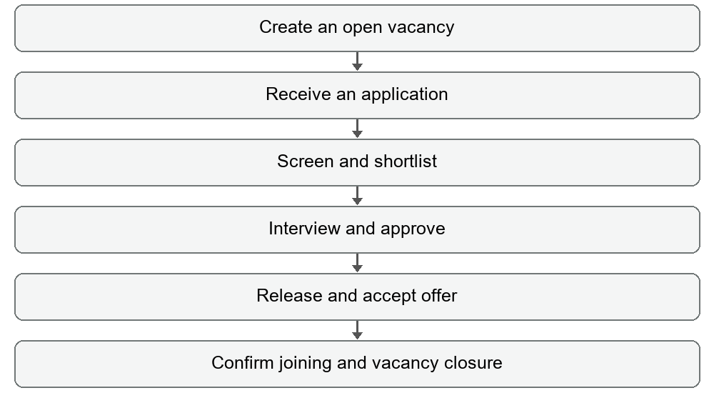  The portal records recruitment activity. Arrange interviews, obtain approvals, send offer letters and contact candidates outside the portal, then record the completed activity here.  Use the numbered sections on the following pages as a practical operating manual. Technical maintainers should also read sections 14 to 16.

Quick reference  Sign in first  Create vacancy  Receive application  Screen CV  Track pipeline  Review reports |  | 1 Find your way around  Guide contents  2 Sign in and manage access  3 Dashboard and daily routine  4 Create a vacancy  5 Move a vacancy through its workflow  6 Submit a public application  7 Add a candidate internally  8 Screen CVs  9 Progress a shortlisted candidate  10 Handle exceptions and joining  11 Search and audit history  12 Reports and CSV exports  13 Worked hiring example  14 Troubleshooting and limitations  15 Local setup for maintainers  16 Project structure and data flow  Navigation  Dashboard gives the operational overview. Vacancies controls job openings. CV Screening is the intake queue. Candidate Pipeline shows shortlisted candidates grouped by stage. Reports provides period and role summaries. Users appears for Admin and Superadmin accounts.  Top bar  Search finds candidates across their recorded details. Open Candidate Form opens the public application page in another tab. + Add Candidate opens internal intake. The name and role badge identifies the signed-in account. Logout asks for confirmation.  Before a hiring cycle  1. Confirm the vacancy title, department, location, responsible employee, salary range and deadline.  2. Obtain a staff account from an administrator and the correct portal URL.  3. Prepare the job description and agree how salary amounts will be expressed. The form does not consistently label a monthly or annual basis.  4. Use accurate Requirement IDs, especially when several vacancies share the same job title.

Access  Applicant  No staff login  Staff  Email and password  Users menu  Admin or Superadmin |  | 2 Sign in and manage access  Sign in and sign out  1. Open the staff portal URL supplied by your administrator.  2. Enter Email Address and Password under Staff Sign In.  3. Click Log In to FMS. On success, the dashboard opens.  4. When finished, click Logout and confirm. The browser otherwise remembers the sign-in locally.  Create a staff account  1. As an Admin or Superadmin, open Users and click + Add User.  2. Enter Full Name, a unique Email Address and Password. The form requires at least six password characters.  3. Select Admin, Recruiter or Superadmin. Click Create User.  4. Wait for the success message and check the account appears in the list. Give credentials to the intended staff member through your normal secure process.  What the roles currently show  Recruiter sees Dashboard, Vacancies, CV Screening, Candidate Pipeline and Reports. Admin also sees Users and can create accounts, including Superadmin accounts. Superadmin additionally sees Delete User for accounts other than the protected primary superadmin.  Delete an account  1. As Superadmin, locate the correct person in Users.  2. Click Delete User and read the confirmation before accepting.  3. Check the refreshed list. The primary superadmin cannot be deleted.  There is no account edit, password change or password reset screen. Ask the technical maintainer for account recovery. Role labels control visible controls; backend access enforcement needs improvement before unrestricted production use, as explained in section 14.

Daily checklist  New applications  Pending screening  Overdue work  Interviews  Recent updates |  | 3 Dashboard and daily routine  Review the dashboard  1. Open Dashboard. Clear any old filter selections with Reset and clear Search when you need the full picture.  2. Choose New Today to review applications received on the current day.  3. Choose Pending CV Screening to find records needing review. Open a candidate name to inspect the profile and CV.  4. Choose TAT Overdue to inspect active candidates beyond their stage target. Contact the responsible person and update the record when work is completed.  5. Choose Interviews Scheduled to review relevant candidate records. Check the actual interview date before acting.  6. Return to All Pipeline for the normal overview.  Read the summaries  Open roles and average days open describe vacancies whose status is Open. Candidate movement groups candidates by current workflow stage. The TAT watchlist shows up to five overdue active candidates. Recent activity shows up to four candidates sorted by their latest stage update.  Use filters intentionally  Choose Date By before entering From and To. You can narrow the dashboard by department, location, priority, responsible employee, source and vacancy status. Date filters and other selections affect the displayed counts.  Understand the preset labels  Although the overdue preset says >3 Days, the calculation uses the target for each candidate stage. For example, new applications have a seven-day target and scheduled interviews have a one-day target. The interview preset also includes candidates with a stored interview date, even after they have moved beyond interviews.  The System Online label is static. It does not confirm a successful database save. Reload after an important update and check that the saved stage or record is still present.

Required preparation  Job title  Department  Location  Deadline  Owner  Optional JD |  | 4 Create a vacancy  Enter the opening  1. Open Vacancies and click + Add vacancy, or use + New vacancy on Dashboard.  2. Choose Job Title and Department from the supplied lists. Select Location: Showroom, Factory or Miracle.  3. Select Priority: Urgent, High, Medium or Low. Check the selection rather than relying on its initial value.  4. Optionally attach a Job Description in PDF, DOC or DOCX format. The backend upload limit is 10 MB.  5. Select Minimum Experience and Salary Range. Enter the required Deadline.  6. Choose Employee Responsible To, then click Save record. Wait for Uploading & Saving to finish.  7. Look in the Manpower tab for the new vacancy. Reload and verify it persists.  Fields and initial values  Date of Opening and Position Code are automatic and cannot be edited in the form. The position code uses the department, title initials and current vacancy count. The new record starts with status Open and stage Manpower Requirement Raised. Its opening and stage-entry timestamps are recorded.  Read the vacancy row  Vacancy Details shows title, ID, location and priority. Owner & Dept identifies the responsible employee and department. Dates shows opening, deadline and eventual filled date. Pipeline Metrics shows Sourced, Interview and Offers counts. Workflow Step shows the current stage, responsible role, expected output and timeline.  The job title, department, location, salary and owner lists are fixed in the source code. There is no settings screen to extend them. There is also no general vacancy edit/delete screen or visible JD download action in the current vacancy row; ask the maintainer for corrections or file retrieval.

Vacancy controls  Complete Step  Moves forward  Status  Controls availability  Log  Shows timestamps |  | 5 Move a vacancy through its workflow  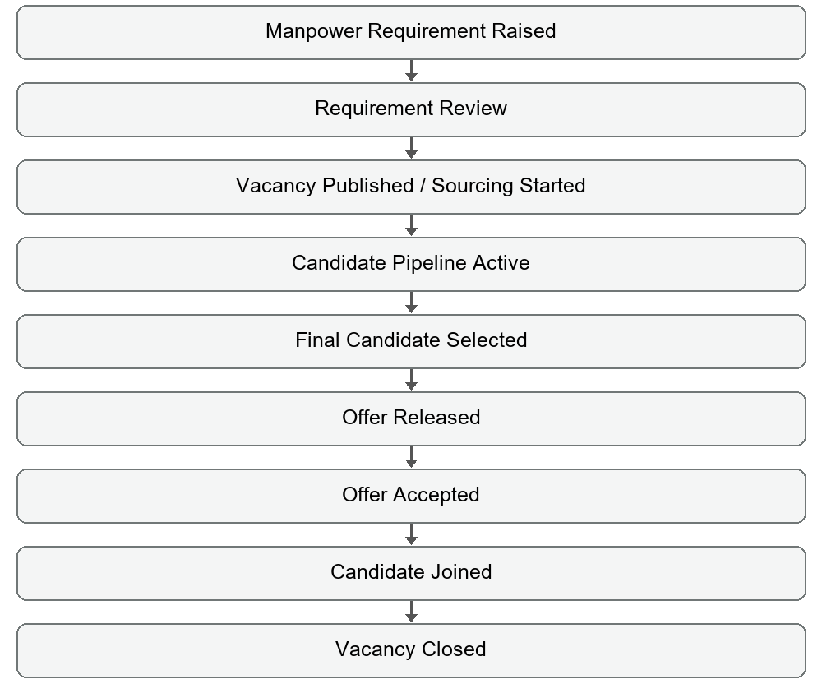  1. Select the current workflow tab and locate the vacancy.  2. Read Responsible and Output. Complete that real-world work first.  3. Check the Next label, then click Complete Step. The record moves forward immediately and the next tab opens.  4. Repeat only as work is completed. Use Step Timestamps & Log to review recorded movement.  Status choices are Open, On-Hold, Cancelled and Closed. Only Open vacancies appear on the public application form and in internal intake. On-Hold and Cancelled do not move the workflow stage. Choosing Closed moves directly to Vacancy Closed and sets the filled date.  Changing a closed vacancy back to Open does not reset its stage or filled date. Candidate interview and offer changes do not automatically advance the matching vacancy stages. Maintain both workflows; candidate joining is the special automatic closure action.

Applicant route  Open Candidate Form  /apply.html  CV required  PDF DOC DOCX  Maximum 5 MB |  | 6 Submit a public application  Share and open the form  Staff can use Open Candidate Form, or applicants can use Open Candidate Application Form from the sign-in page. Share the deployed portal address ending in /apply.html. A localhost address works only on the computer running the application.  Complete the application  1. Select Position Applied for. The list includes vacancies with status Open.  2. Enter Full Name, Date of Birth and Gender. Future dates of birth are disallowed.  3. Enter a Phone number with exactly ten digits and a valid Email ID.  4. Enter Residential Address and Current Location of Job, including the area where useful.  5. Choose Total Working Experience and enter top Skills. These are required.  6. Optionally enter Marital Status, Expected Salary, Notice Period in days and Platform applied through.  7. Attach the required CV or Resume in PDF, DOC or DOCX format, up to 5 MB. Optionally add other information.  8. Click Submit Application and wait. If the same phone number exists, the form asks whether to submit again. Confirm only for an intentional second application.  9. After Application Submitted appears, HR should reload the portal and verify the candidate record and CV link.  What happens next  The application receives an automatic candidate ID, links to the vacancy and enters Application Received (New) with screening status Pending Review. It is ready for CV Screening.  A missing source defaults to Direct. The form saves personal details and skills. It does not send an automatic interview invitation or offer. A submission success screen alone does not guarantee database persistence; see section 14 for the current save-handling limitation.

Internal intake  + Add Candidate  + Add application  Required  Vacancy link  Name  Mobile number |  | 7 Add a candidate internally  Create the record  1. Click + Add Candidate in the top bar, or + Add application in CV Screening.  2. Choose Requirement ID (Link to Vacancy). The selection includes open vacancies and establishes the applied role. If no vacancy is available, create or open the appropriate vacancy first.  3. Enter Candidate Name and Mobile Number. The Candidate ID is generated automatically.  4. Enter Email ID, Current Location of Job, Expected Salary, Notice Period in days and Total Working Experience in years as available.  5. Select the application Source. You can choose options including Naukri and Consultant in internal intake. A blank source becomes Direct.  6. Attach an optional CV/Resume in PDF, DOC or DOCX format, within the backend 10 MB limit. Enter Any Other Information for useful notes.  7. Click Save record. Open CV Screening and locate the candidate by name, phone or ID. Reload to confirm the record was saved.  Fields that currently do not persist  The internal form displays Gender, Date of Birth, Marital Status, Residential Address, Current Salary, Top Skills and Referred By / Consultant Name, but its save code does not copy those values into the candidate record. Do not rely on these fields being retained through internal intake.  For full personal details and skills, use the public application form. For information it does not collect, such as current salary or referrer name, use Any Other Information until the maintainer fixes the internal save mapping.  Review the profile  Click the candidate name to see contact information, application details, screening notes and the timeline. View CV / Resume opens an uploaded file in a new tab. This is a viewing screen; it is not a general profile editor.

Screening states  Pending Review  Shortlisted  Rejected  Hold |  | 8 Screen CVs  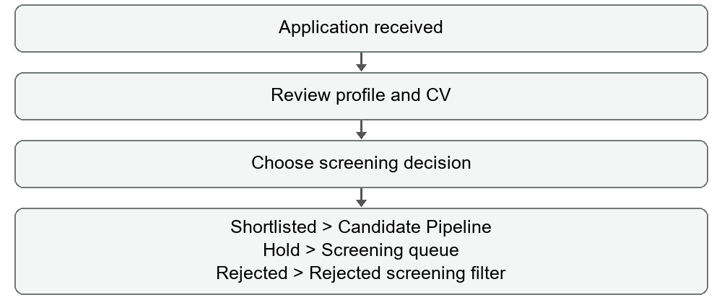  Make a screening decision  1. Open CV Screening. By default it shows Pending Review, Hold and records with no screening status.  2. Use role, source, department or date filters to find the relevant applications.  3. Click a candidate name and open the CV. Assess the person against the vacancy requirements outside the system.  4. Choose Shortlisted in Screening Action to move the candidate to CV Screened & Shortlisted. A confirmation alert appears and the candidate becomes visible in Candidate Pipeline.  5. Choose Hold to set screening status Hold and candidate stage On Hold. The candidate remains in the default screening queue.  6. Choose Rejected to open the rejection form. Select a reason, add useful remarks or next-action details and click Save stage update.  Find a processed application  Set the Screening filter to Shortlisted or Rejected to see records removed from the default queue. Reset restores the normal pending-and-held view.  Screening status is separate from candidate stage. Changing the dropdown to Pending Review does not automatically reset the stage. Re-selecting Shortlisted on an advanced candidate can move the candidate back to CV Screened & Shortlisted. Use screening changes deliberately; there is no dedicated undo action.

Pipeline actions  Move to next step  Stage dropdown  Save stage update  Confirm the full  stage name |  | 9 Progress a shortlisted candidate  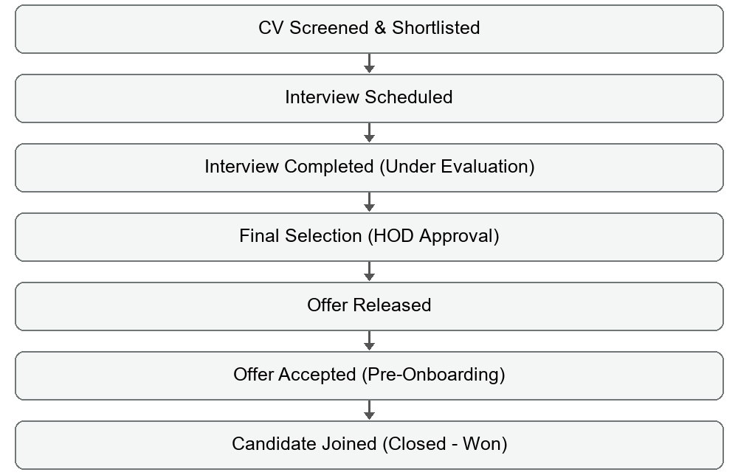  1. Open Candidate Pipeline and choose the current stage tab. Only candidates with screening status Shortlisted appear here.  2. Use the row action Move to ... to advance to the next stage. The button abbreviates the name, so read the full stage in the form.  3. For Interview Scheduled, enter Interview date, Interview time and Interviewer name. Save stage update.  4. For Interview Completed (Under Evaluation), enter a rating from 0 to 10 and required interview remarks. Save.  5. Move to Final Selection (HOD Approval) after obtaining approval outside the portal. This stage change is immediate.  6. For Offer Released, enter Offer release date and Offered CTC. Send the actual offer outside the portal.  7. For Offer Accepted (Pre-Onboarding), enter Expected joining date after acceptance.  8. In each stage form, use Next action, Next action due date and Additional remarks to record follow-up work before saving.  Use the stage dropdown when a deliberate non-sequential change is needed. Some changes act immediately without a form. Changing a stage does not send messages, book a calendar event or generate documents.

Exceptions  Hold  Immediate  Drop  Immediate  Reject  Reason required  Joined  Closes vacancy |  | 10 Handle exceptions and joining  Hold and Drop  Hold sets On Hold immediately. Drop sets Dropped / Ghosted immediately. Neither opens a reason or follow-up form, even though workflow descriptions refer to those details. Add useful notes in an available stage-update form beforehand when appropriate, or retain them through your team process.  Reject a candidate  1. Click Reject or select Rejected in the stage dropdown.  2. Choose High salary expectation, Lack of skills, Culture fit, Notice period or Other.  3. Enter any useful next action, due date and additional remarks.  4. Click Save stage update. Rejection from CV Screening also changes screening status to Rejected. Rejection from the pipeline retains Shortlisted screening status, so the record remains in its Rejected pipeline tab.  Resume or correct a held record  For a screening-held applicant, choose Shortlisted in CV Screening to begin the pipeline. For a pipeline-held candidate, use the stage dropdown to select the appropriate stage. Joined, Rejected and Dropped records have no forward action buttons, but the stage dropdown remains available. There is no automatic restoration of a previous stage.  Confirm joining  1. Verify the person actually joined and check the Requirement ID carefully.  2. Move the candidate to Candidate Joined (Closed - Won). No separate actual-joining-date form opens.  3. Open Vacancies and check the Closed tab. The app sets the matched vacancy to Vacancy Closed, status Closed, and a filled date based on the current UTC date.  4. Reload and check both records. Complete onboarding through your normal process.  Matching can use the job title as well as Requirement ID. Duplicate titles can cause the wrong vacancy to close. Moving the candidate out of Joined does not reopen the vacancy. The expected joining date can remain in the profile; the stage log records when joining was marked.

Find records  Clear Search  Reset filters  Check stage tab  Audit  Entry time  Completion time  Duration |  | 11 Search and audit history  Search and filter  1. Enter a candidate name, ID, phone, email, role, skill, location or other recorded detail in Search. All space-separated search terms must occur somewhere in the candidate details.  2. Use Date By to choose the date you mean, such as Application Date, Stage Updated, Interview Date or Next Action Date.  3. Set From and To. The end date includes the full day. Add the relevant dropdown filters.  4. Select the correct workflow tab. Filters and stage tabs work together.  5. To find a missing record, clear Search, click Reset, and check another tab or the Screening filter.  Search is applied to candidates on Dashboard, CV Screening and Candidate Pipeline. It is not a universal search for Vacancies, Reports or Users. Filters are independent for each view and remain selected while navigating the current session.  Inspect a timeline  1. On a vacancy, click Step Timestamps & Log. On a candidate, use the stage log control or open the profile and click Full Audit Log.  2. Read the current stage start time and elapsed duration.  3. Review the Step-by-Step Transition Log for the prior stage, destination, entry and completion timestamps, duration and notes.  4. Use the Full Workflow Stepper to understand completed, current and future steps.  TAT targets  Candidate targets are: new application 7 days; shortlisted 1; interview scheduled 1; evaluation 3; final selection 3; offer released 1. Offer accepted and On Hold have no fixed target. Joined, Rejected and Dropped are terminal states. Overdue uses elapsed stage days and the configured target, not the next-action due date.  Vacancy targets are: manpower same day; review 1 day; sourcing 1; pipeline no fixed target; final selection 1; offer released same day; offer accepted 3; joined no fixed target; closed same day. These owners and targets are workflow guidance, not enforced approval gates.

Report periods  Daily  Today  Weekly  Last 7 days  Monthly  Last 30 days  Vacancy  All time before filters |  | 12 Reports and CSV exports  Generate a report  1. Open Reports and choose Daily Report, Weekly Report, Monthly Report or Vacancy Report.  2. Set Date By, From and To only when you need an additional record filter. Select department, location, priority, owner, source or status as needed.  3. Review the summary cards and role-wise rows. The table groups records by job title, not by unique Requirement ID.  4. Click the CSV export button. Open the downloaded Recruitment_...csv file in Excel or another spreadsheet application.  5. Check the selected period, filters, role rows and TOTAL row before sharing the file.  Understand the columns  Candidates Reached / Forms Filled counts candidate records created in the report period; it is not a count of phone calls or outreach. Shortlisted is based on screening or stage history with an additional current-stage-update period check.  Telephonic Interview corresponds to Interview Scheduled. HR Interview corresponds to Interview Completed (Under Evaluation). Final Interview corresponds to Final Selection (HOD Approval). These labels do not establish separate telephonic, HR and final interview rounds.  Offers counts candidates who match Offer Released or Offer Accepted. Vacancy Filled counts candidates who match Candidate Joined. These metrics consult current stage and movement history and count candidates, not the number of stage-change events. A candidate can contribute to several columns.  Avoid misleading comparisons  Weekly and Monthly are rolling seven-day and thirty-day periods, not calendar week and calendar month. Additional filters narrow the input records before period metrics are calculated, so a custom date range does not replace the chosen report period. Identical role names are combined, including openings across departments.  CSV is a report export, not a backup of candidate profiles, uploaded files, users or complete history. The global Search field does not filter report exports.

Illustrative example  Role  Sales Executive  Purpose  Practice the sequence  Use test data only  in a test environment |  | 13 Worked hiring example  From opening to joining  1. Create an open Sales Executive vacancy. Select the appropriate department, location, priority, salary range, deadline and responsible employee. Note its generated ID.  2. In Vacancies, complete the manpower and requirement-review steps after approval. Move to sourcing when the job is published outside the portal.  3. Have a test applicant use /apply.html, choose the opening, complete the required details and upload a small PDF CV.  4. Reload the staff portal. In CV Screening, search for the applicant, open the profile and confirm the CV is accessible.  5. Choose Shortlisted. In Candidate Pipeline, open CV Screened & Shortlisted and schedule the interview with its date, time and interviewer.  6. After the interview, move to evaluation and record the rating and remarks. Obtain the HOD decision, then mark Final Selection.  7. Keep the vacancy workflow aligned by completing its pipeline and selection steps as the real work finishes.  8. Release the actual offer outside the portal. Record Offer Released and the offered amount, then record acceptance and the expected joining date.  9. On actual joining, verify the link and mark Candidate Joined. Check the matching vacancy has closed automatically.  10. Review both audit logs, reload to verify persistence, and export the relevant report.  End of day checks  Confirm new applications have a CV and the correct vacancy link. Check overdue work and upcoming interview dates. Review records awaiting acceptance or joining. Make sure closed openings no longer appear in the public form. Reconcile the role report with candidate records before sharing it.  Maintain separate communication and document processes: this project does not provide email or SMS delivery, calendar booking, offer-letter generation, onboarding task management or an automatic reminder service.

Check in order  Filters and tabs  Backend connection  Saved record  Uploaded file  Administrator support |  | 14 Troubleshooting and limitations  A record seems missing  Clear Search and Reset the view filters. Check the correct stage tab. For intake, set the Screening filter explicitly. The pipeline only includes Shortlisted screening status. Reload for submissions made in other tabs or by applicants; there is no automatic live refresh.  Saving looks successful but data is missing  Internal saves update the screen before database confirmation and do not check HTTP error responses. The public success message can also appear after a server error response. Reload and inspect the record. Ask the maintainer to check /api/sync responses and MongoDB connectivity before re-entering data.  The CV is missing  Check View CV / Resume in the profile. Upload failures may still allow the record to save without a file link. Verify file size and format and ask the maintainer to check Cloudinary settings. There is no existing-record CV replacement screen. Avoid creating duplicate applicants merely to retry an attachment.  Login or account creation fails  Recheck email and password. Duplicate email addresses are rejected when creating users. A backend or database problem can also prevent login. Contact the administrator for recovery; there is no Forgot Password action.  Limitations maintainers must address  API routes currently lack authenticated session/token checks and server-side role authorization. The public form uses the same data endpoint that returns vacancies and candidates. Browser-stored role information and hidden buttons are not sufficient access controls. Restrict exposure until these issues are corrected.  Bulk sync sends full in-memory record collections; simultaneous users or stale public forms can overwrite newer values. Count-based IDs can collide. Coordinate updates and use one active editor per record until concurrency and ID handling are improved.  Internal intake omits several fields from saving. Duplicate job titles affect vacancy matching and reports. Stage history is an operational log, not an immutable compliance audit. No candidate/vacancy delete screen, general edit screen or application backup/restore tool is provided.

Project folder  E:\Recruitment FMS  Frontend  Port 5173  Backend  Port 3000  External services  MongoDB  Cloudinary |  | 15 Local setup for maintainers  Prepare configuration  1. Use a Node.js installation compatible with the locked Vite and server dependencies, plus npm. Open a terminal in E:\Recruitment FMS.  2. Install the locked dependencies with npm ci. Do not copy node_modules between incompatible machines.  3. Provide MONGODB_URI, CLOUDINARY_CLOUD_NAME, CLOUDINARY_API_KEY and CLOUDINARY_API_SECRET in the local .env file. Obtain values from the service administrator. Keep them out of shared documents and version control.  4. Ensure MongoDB permits the application connection and the configured database user has the required access. Cloudinary is required for file uploads.  Start and check  1. Run npm run dev. It starts node server.js and the Vite frontend together.  2. Open http://localhost:5173 for staff and http://localhost:5173/apply.html for applicants. The frontend routes API requests to http://localhost:3000 at this exact local port.  3. Confirm the backend terminal reports its port and successful database connection.  4. Sign in using the administrator-provisioned account. Check data loading and, in a test database, record saving and file uploading.  5. Stop the development processes with Ctrl+C when finished.  Configuration details  PORT can change the backend listener, but the local frontend address is hardcoded to port 3000 when Vite runs at 5173. If Vite moves to another port, the code uses same-origin API URLs and requests may fail. Keep the expected ports available or update API routing deliberately.  On a new database, server.js seeds a primary Superadmin using credentials embedded in the source. Replace that bootstrap design and rotate credentials through a controlled maintenance process before broader use. The user interface has no password-change function.  Build and host  npm run build creates dist. npm run preview serves the frontend only and needs deliberate API routing. api/index.js exports Express; vercel.json routes /api to it. Configure hosting environment variables and check API and static routes.

Maintenance reference  Frontend  Vite and JavaScript  API  Express  Database  Mongoose  Files  Cloudinary |  | 16 Project structure and data flow  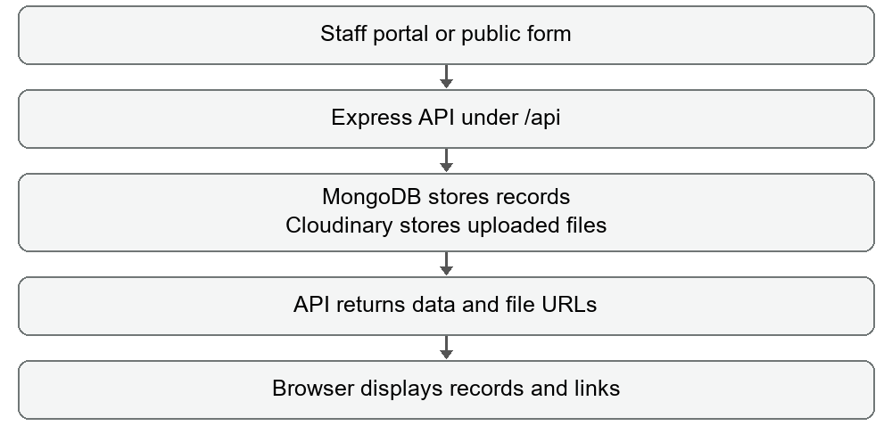  Main project files  src/main.js contains sign-in, navigation, dropdown lists, dashboards, filters, vacancy controls, screening, pipeline, reports and user management. src/style.css controls portal styling. public/apply.html is the standalone public application form. index.html loads the frontend.  server.js handles database connection, file uploads, login, user management, record saves and bulk sync. models/Vacancy.js, models/Candidate.js and models/User.js define stored fields and indexes. api/index.js and vercel.json provide the serverless API entry and routing. package.json defines dev, build and preview commands.  API reference  GET /api/data reads vacancies and candidates. POST /api/sync upserts supplied collections. POST /api/upload accepts a file and returns its hosted URL. POST /api/vacancies and /api/candidates are dedicated save endpoints; current forms mainly use upload plus bulk sync.  POST /api/auth/login verifies credentials. GET /api/auth/users lists users. POST /api/auth/users creates an account. DELETE /api/auth/users/:id removes an account except the protected primary superadmin. These routes require the access-control improvements described in section 14.  Terms  FMS: workflow management in this portal. JD: job description. CV: resume. HOD: head of department. CTC: compensation amount. TAT: target turnaround time. Requirement ID: vacancy identifier. Stage timestamp: recorded entry or completion time. Screening status: intake decision that determines pipeline visibility.  Source reviewed 04 September 2026.

